**Experiment-4:**

Exercises to solve real world problems using the following machine learning methods:

a) Linear regression b) Logistic regression c) Binary classifier

**a)Linear Regression**

Linear regression shows the linear relationship between the independent(predictor) variable i.e. X-axis and the dependent(output) variable i.e. Y-axis, called linear regression. Linear regression analysis is used to predict the value of a variable based on the value of another variable. The variable you want to predict is called the dependent variable. The variable you are using to predict the other variable's value is called the independent variable.Linear regression is a fundamental machine learning algorithm used for predicting numerical values based on input features. It assumes a linear relationship between the features and the target variable.

Since the Linear Regression algorithm represents a linear relationship between a dependent (y) and one or more independent (y) variables, it is known as Linear Regression. This means it finds how the value of the dependent variable changes according to the change in the value of the independent variable. The relation between independent and dependent variables is a straight line with a slope.The model learns the coefficients that best fit the data and can make predictions for new inputs.

Linear regression can be expressed mathematically as:

y= β0+ β1x+ ε

Here,

Y= Dependent Variable

X= Independent Variable

β 0= intercept of the line

β1 = Linear regression coefficient (slope of the line)

ε = random error

The last parameter, random error ε, is required as the best fit line also doesn't include the data points perfectly.

Example:



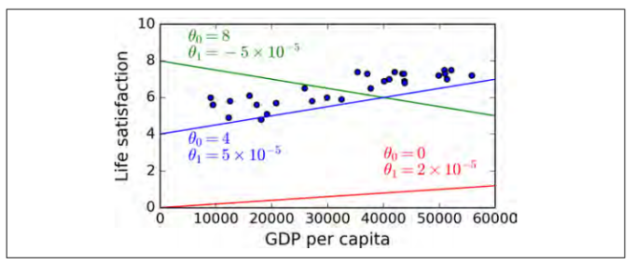

**Linear Models**

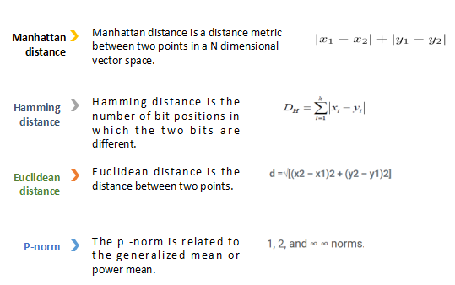

## b)Logistic Regression

Logistic regression is a supervised machine learning algorithm mainly used for classification tasks where the goal is to predict the probability that an instance of belonging to a given class. It is used for classification algorithms its name is logistic regression. it’s referred to as regression because it takes the output of the linear regression function as input and uses a Sigmoid function to estimate the probability for the given class. The difference between linear regression and logistic regression is that linear regression output is the continuous value that can be anything while logistic regression predicts the probability that an instance belongs to a given class or not.

Logistic regression predicts the output of a categorical dependent variable. Therefore the outcome must be a categorical or discrete value. It can be either Yes or No, 0 or 1, true or False, etc. but instead of giving the exact value as 0 and 1, it gives the probabilistic values which lie between 0 and 1.

Logistic Regression is much similar to the Linear Regression except that how they are used. Linear Regression is used for solving Regression problems, whereas Logistic regression is used for solving the classification problems.

In Logistic regression, instead of fitting a regression line, we fit an "S" shaped logistic function, which predicts two maximum values (0 or 1).

Logistic regression aims to solve classification problems. It does this by predicting categorical outcomes, unlike linear regression that predicts a continuous outcome.

In the simplest case there are two outcomes, which is called binomial, an example of which is predicting if a tumor is malignant or benign. Other cases have more than two outcomes to classify, in this case it is called multinomial. A common example for multinomial logistic regression would be predicting the class of an iris flower between 3 different species.

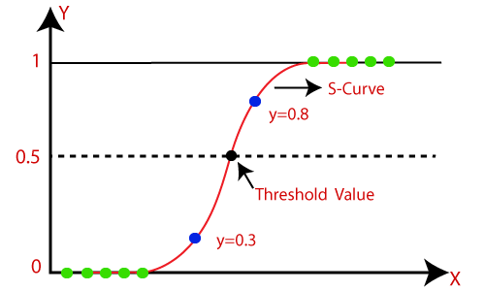

c) **Binary Classifier**

Binary classification is the task of classifying the elements of a set into one of two groups (each called class) on the basis of a classification rule.

In a binary classification task, the goal is to classify the input data into two mutually exclusive categories. The training data in such a situation is labeled in a binary format: true and false; positive and negative; 0 and 1; spam and not spam, etc. depending on the problem being tackled.

For instance, we might want to detect whether a given image is a truck or a boat.

In a medical diagnosis, a binary classifier for a specific disease could take a patient's symptoms as input features and predict whether the patient is healthy or has the disease. The possible outcomes of the diagnosis are positive and negative.